Last Repeating Integer

N integers are passed as the input.

The program must print the last repeating integer among the N integers.

Boundary Condition(s): 1 <= N, value of integers <= 1000 Input Format:

The first line contains the integer N. The second line contains N integers separated by space(s).

Output Format: The first line contains the last repeating integer.

Example Input/Output 1: Input: 6 1 2 1 5 2 7 Output: 2

Example Input/Output 2: Input: 7 12 34 34 34 12 45 67 Output: 12

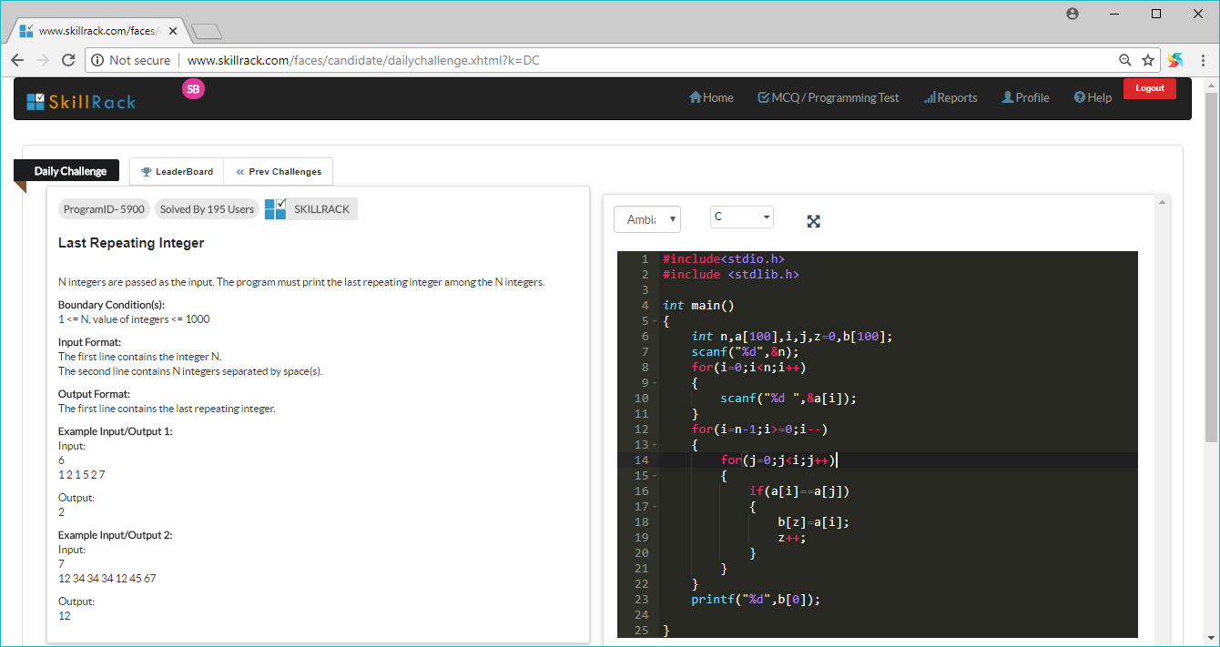

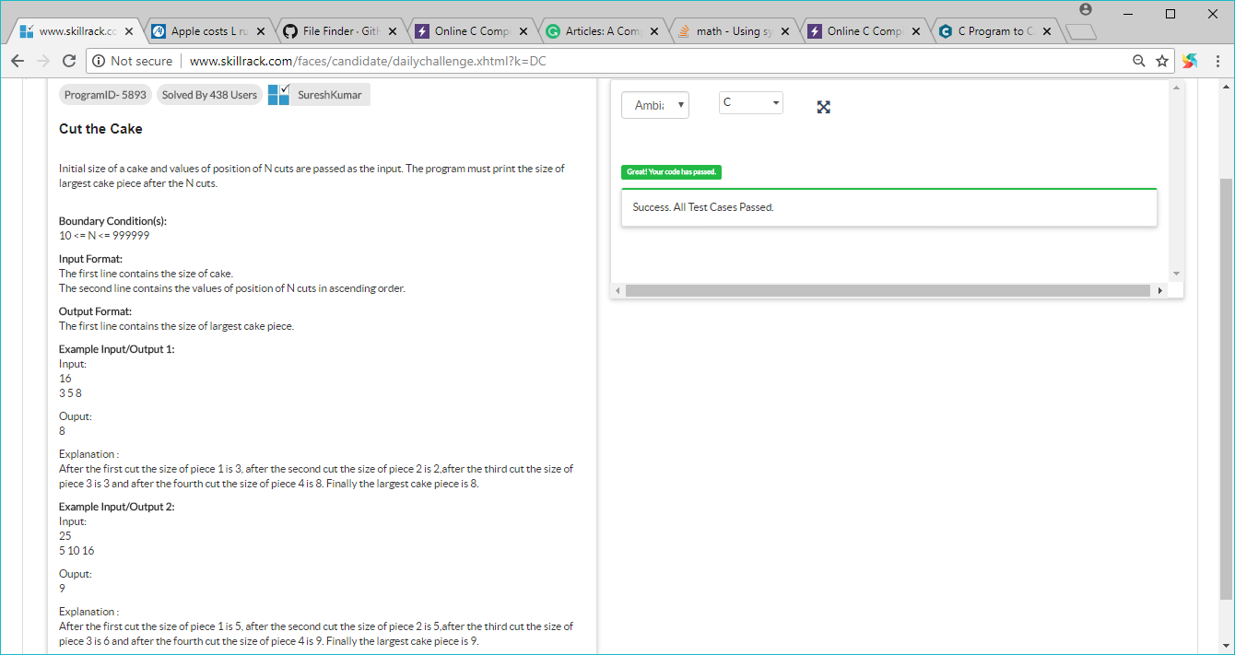

#include<stdio.h>

#include <stdlib.h>

int main()

{

int a,b,i=0,max[100],k,j,sum=0,temp;

scanf("%d",&a);

while(scanf("%d[^\n]",&b)>0)

{

max[i]=b-sum;

sum=b;

i++;

}

max[i]=a-b;

for(j=0;j<=i;j++)

{

for(k=j+1;k<=i;k++)

{

if(max[j]<max[k])

{

temp=max[j];

max[j]=max[k];

max[k]=temp;

}

}

}

printf("%d",max[0]);

}

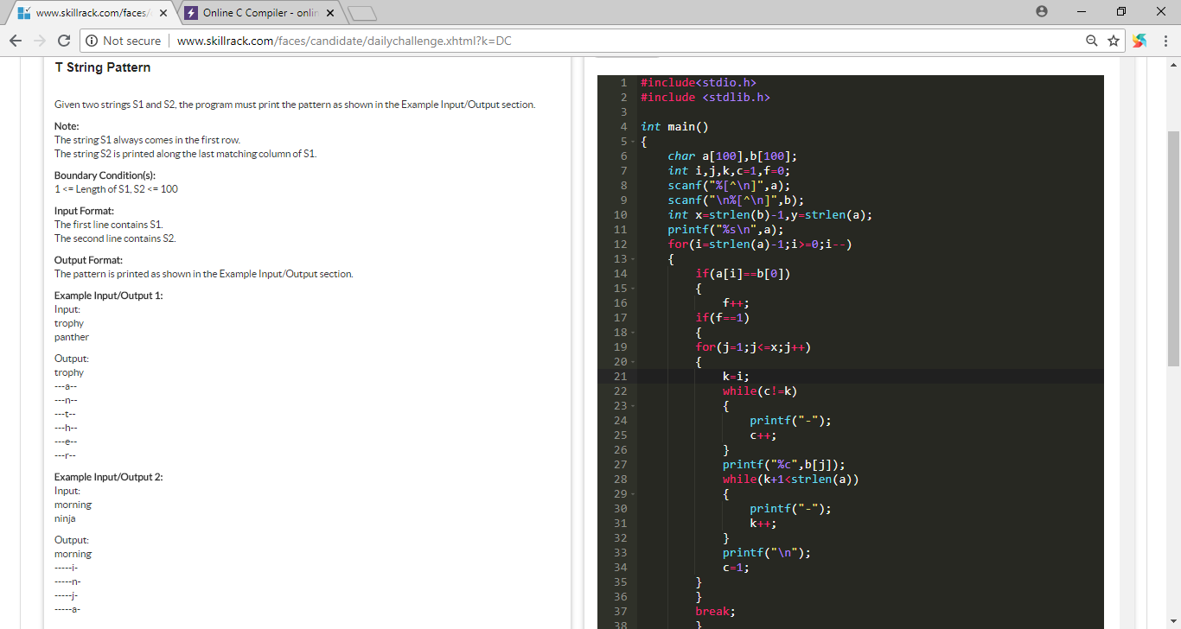

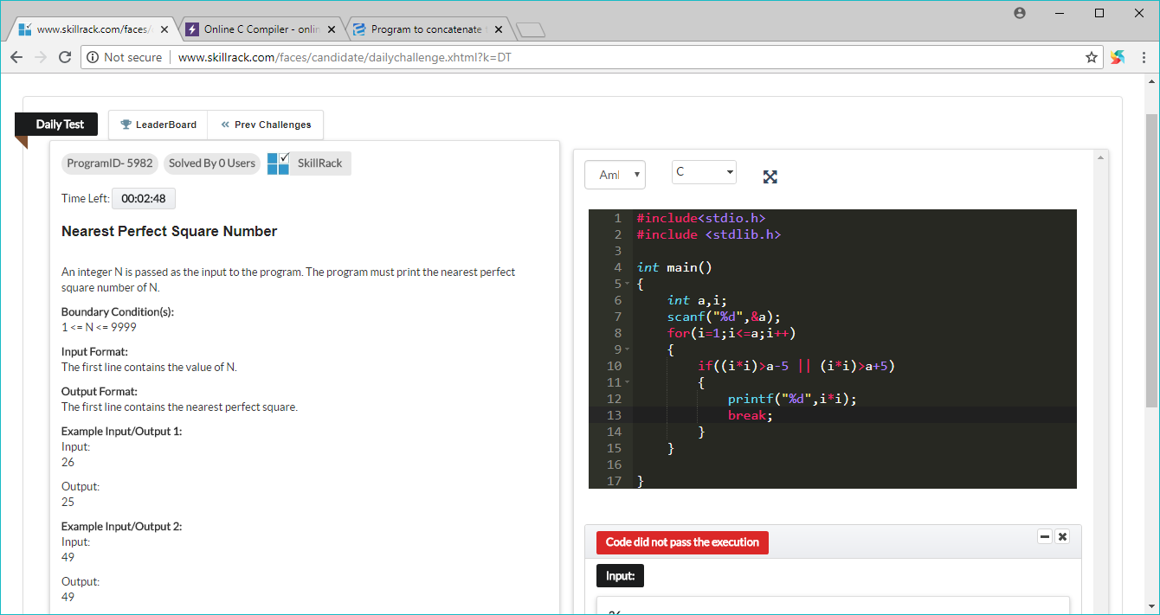

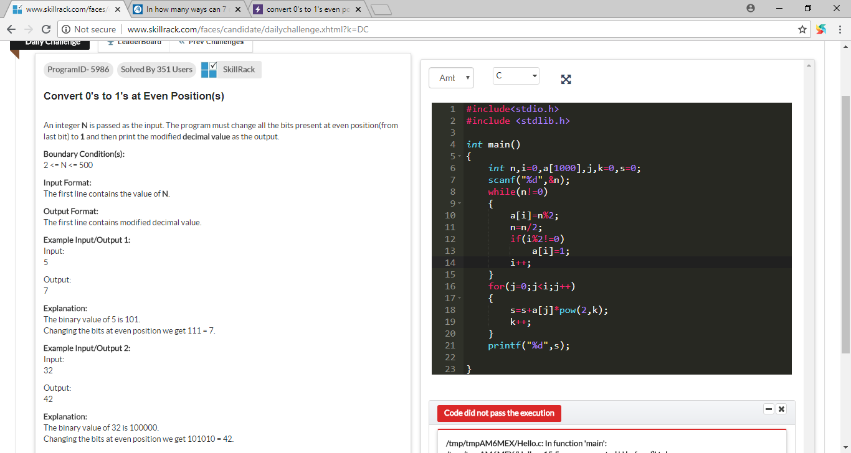

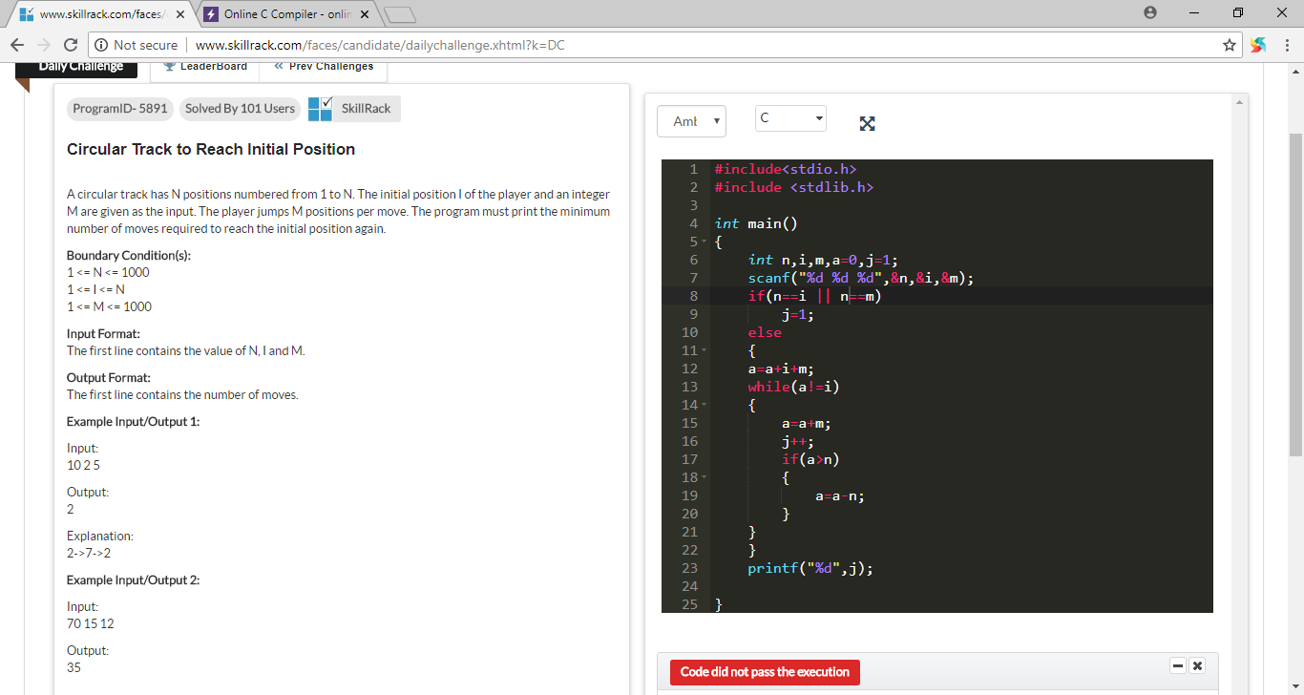

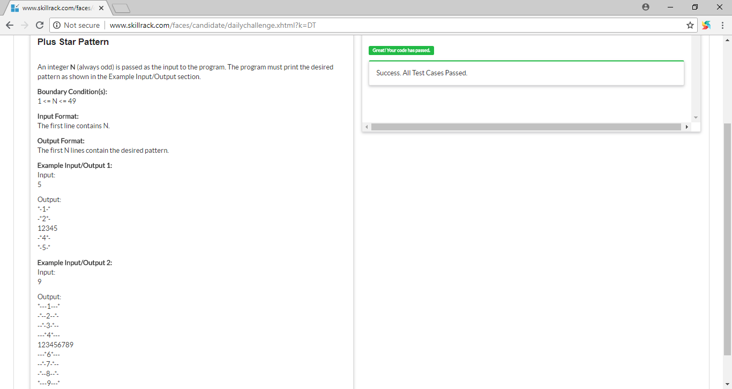

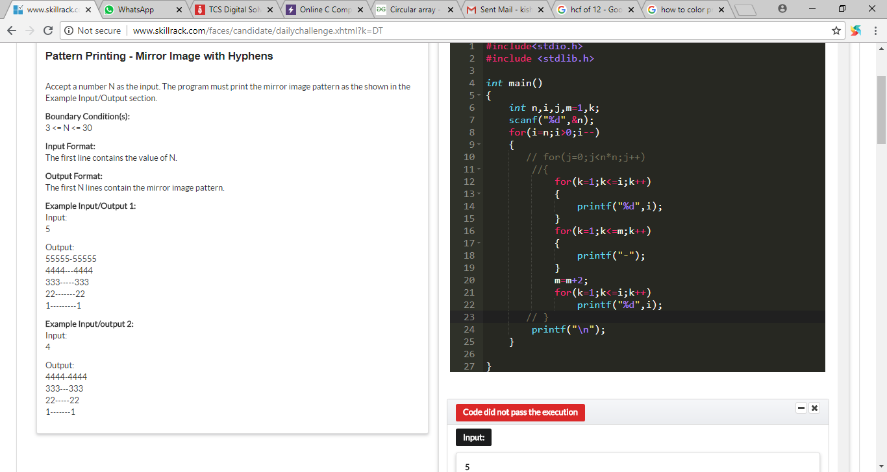

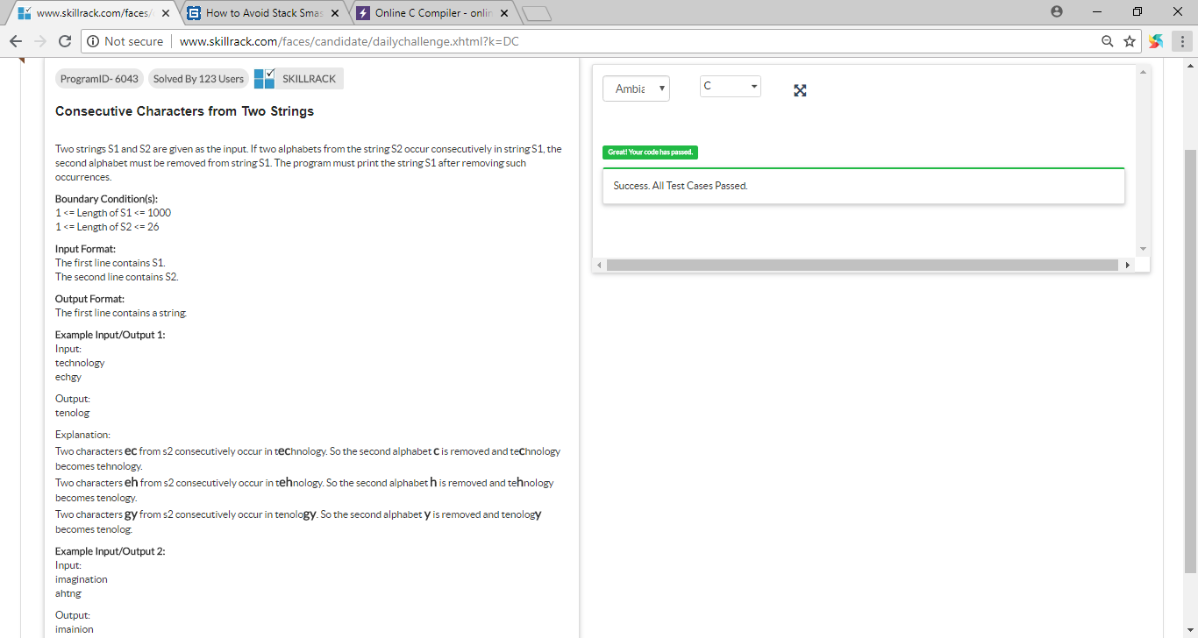

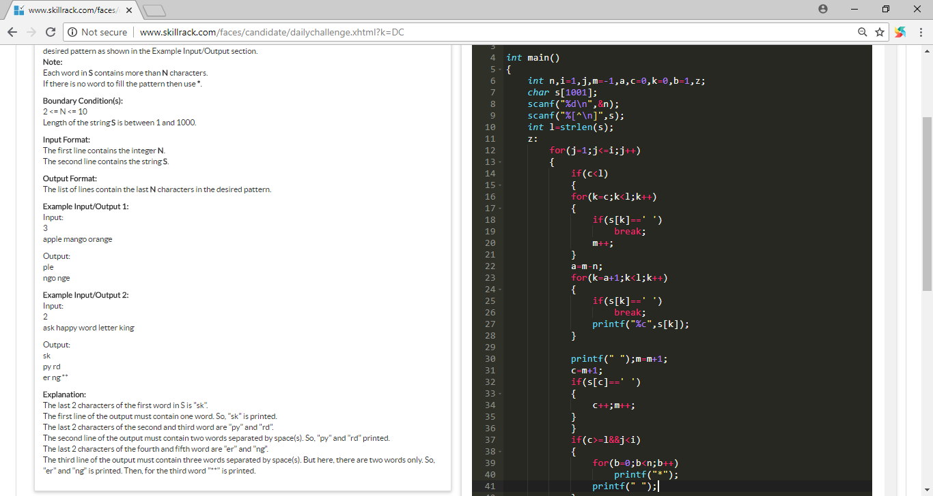

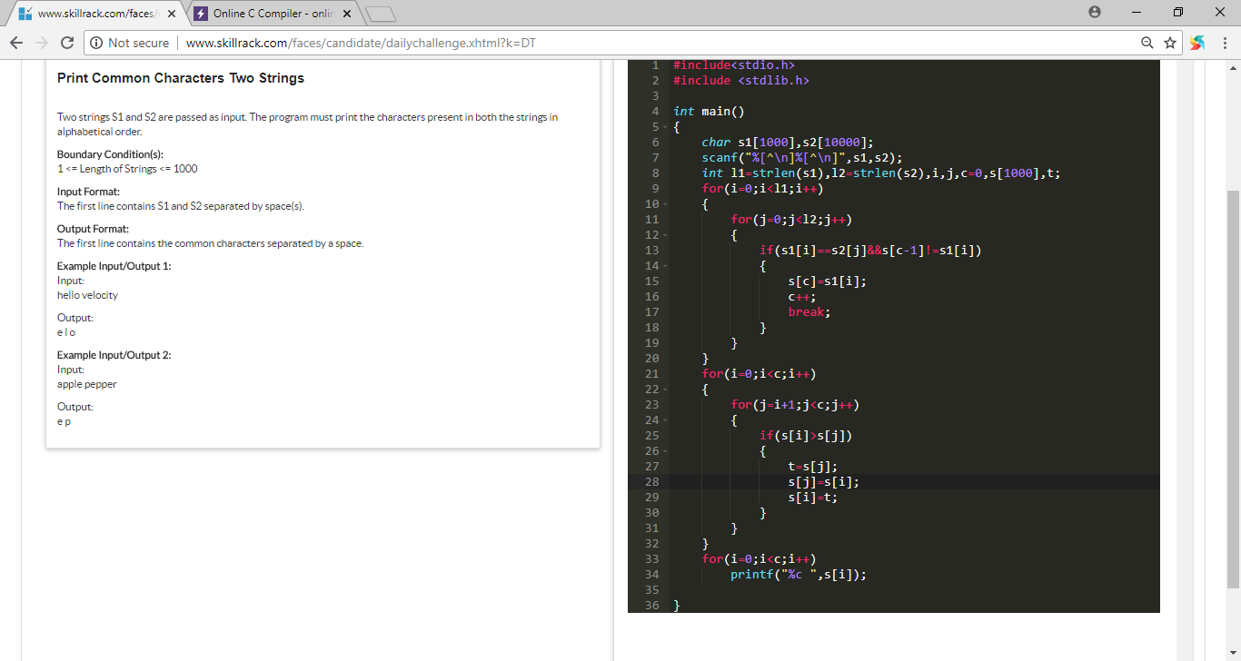

28/07/2018

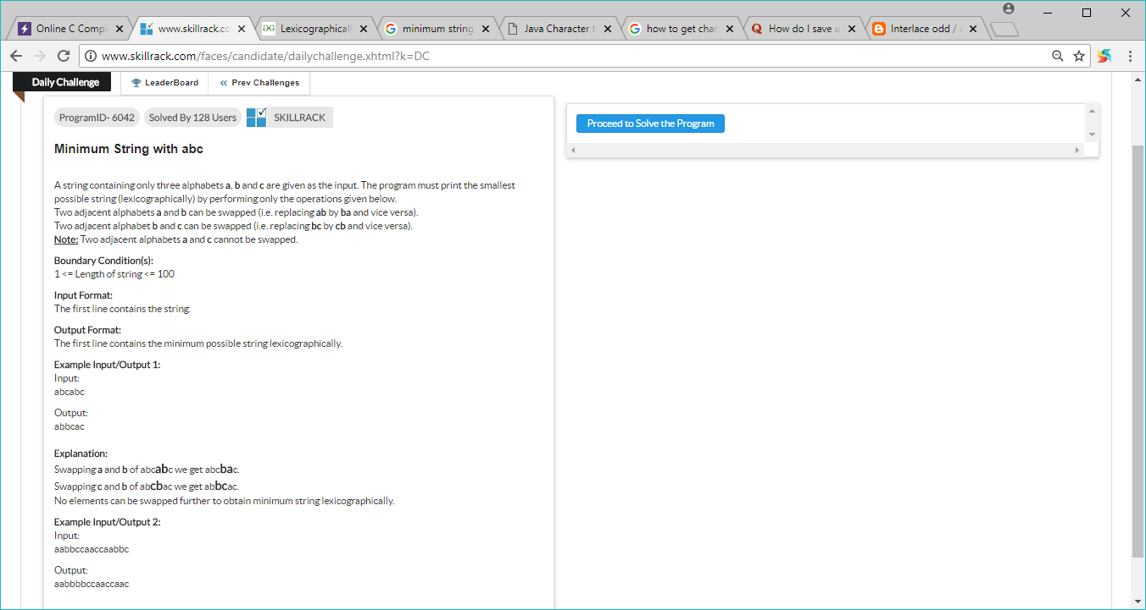

Test case:

abcabc=abbcac

aabbccaaccaabbc=aabbbbccaaccaac

aaccaacac=same

cbacba=bbcac

bbaaccbb=aabbbbcc

ba=ab

29/07/2018

